NaveenBonala IAM

1. Create one IAM user and assign ec2,s3 full access role.

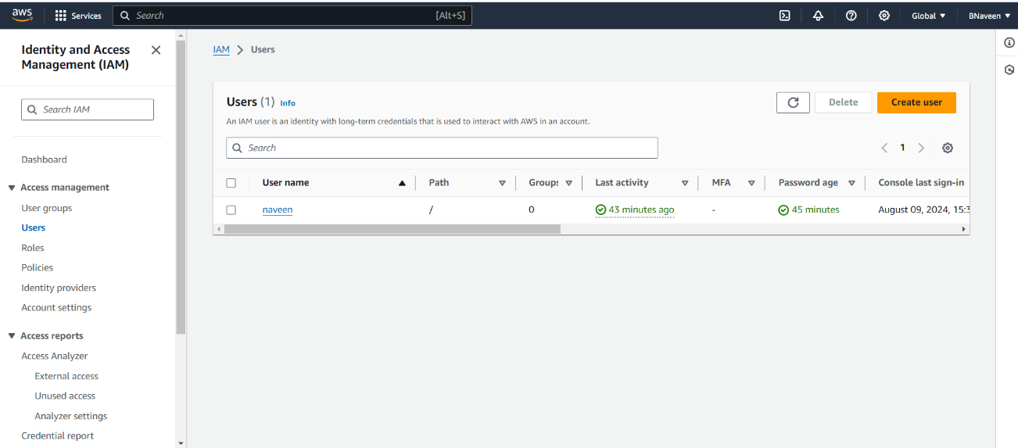

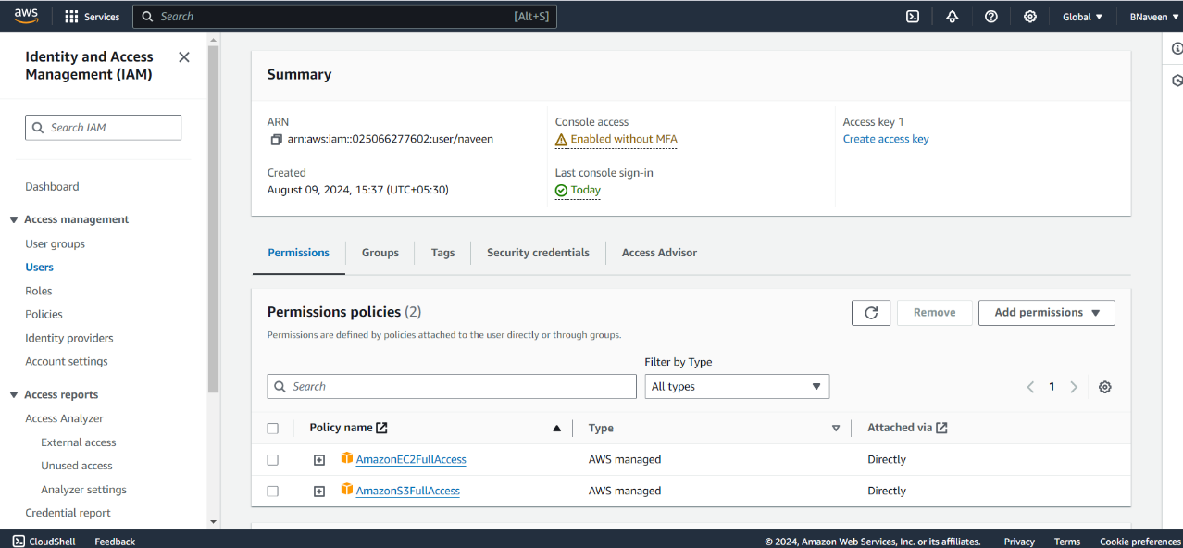

Create one Group in IAM and Assign Read access for ec2.

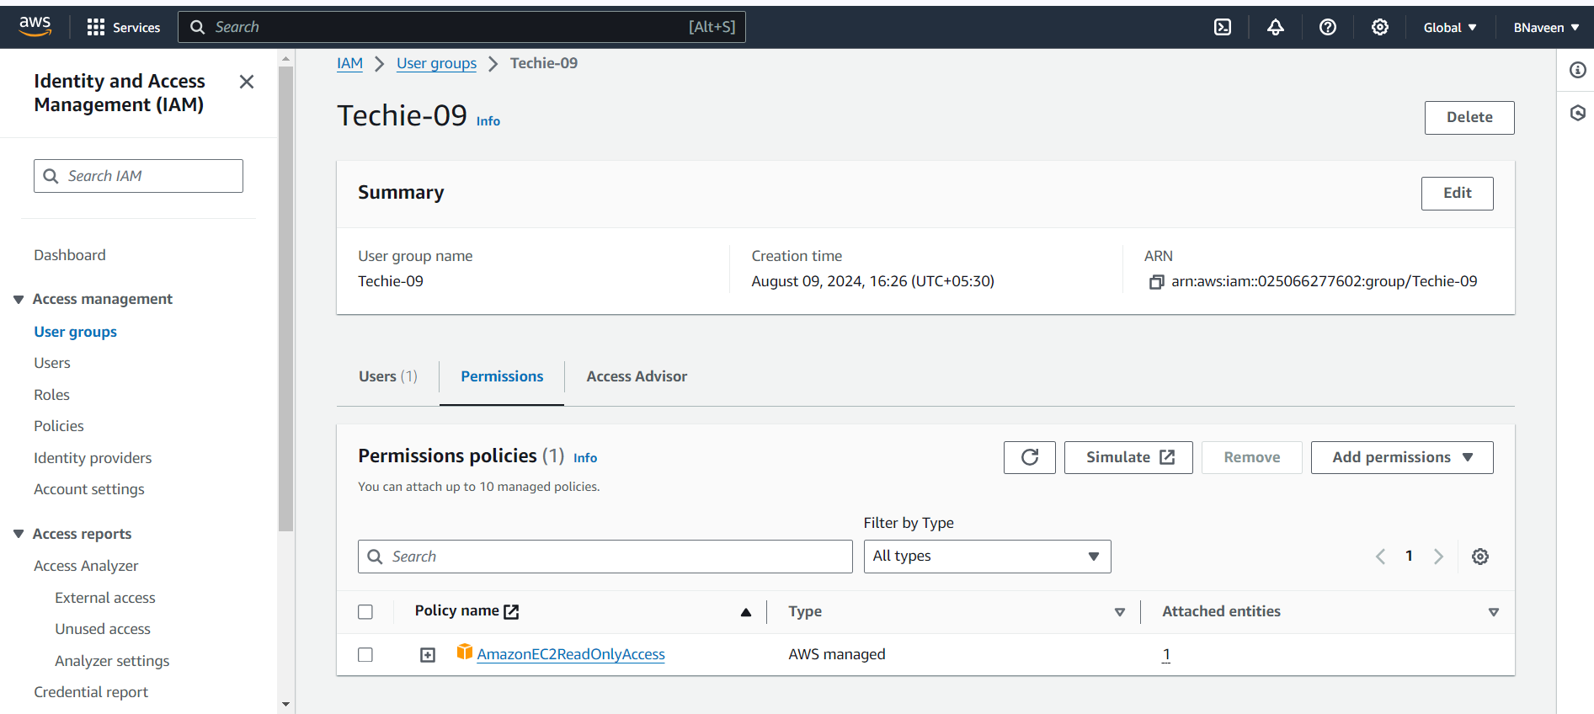

Create a new user with name Devops and add to the group created in task2.

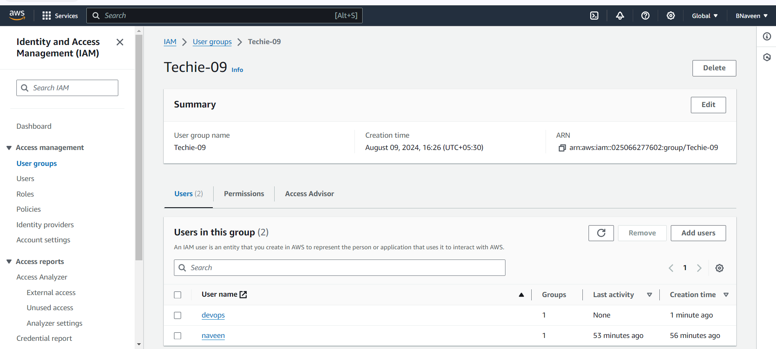

4) Write a bash script to create a IAM user with VPC full access.

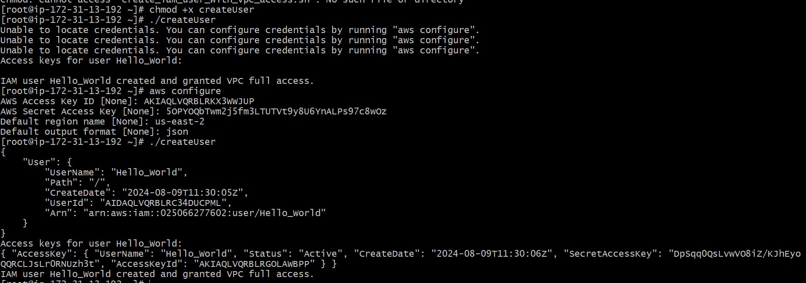

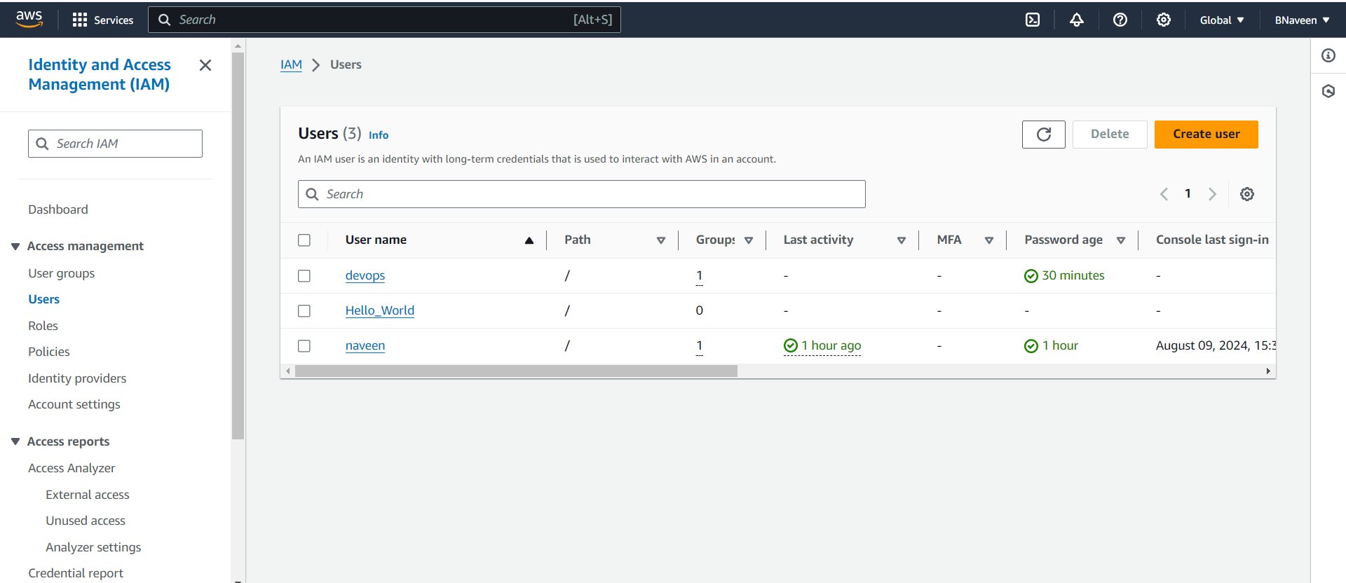

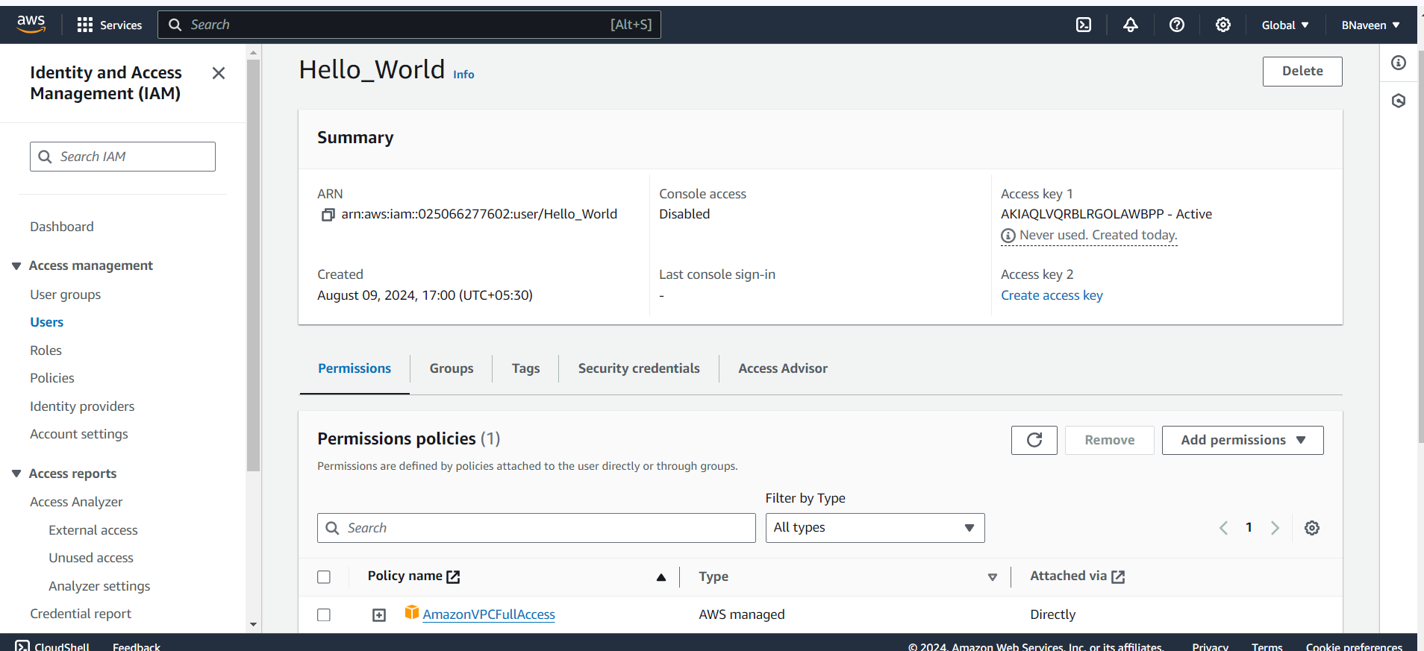

5) Create a IAM policy to access ec2 for a specific user in specific regions only.

